May 2016

Dear Referring Practitioner please get some new info on the run... General Medicine Bulletin 3
Antibiotic Prescribing

Antibiotic prescribing in the face of increasing resistance

As you will most probably know, the world is running out of antibiotic choices. Resistant mutations evolve quicker than the development of new antimicrobial drugs. This situation can lead to a real apocalypse when we ran out of antimicrobial choices. During the past year this reality came a bit closer to us in Bloemfontein. The world ran out of antibiotic choices in some ICU patients with detrimental results. Therefore antibiotic stewardship is extremely important. It currently is a worldwide strategy.

Antibiotic stewardship consist of bundles of strategies. There are general strategies for example hand wash, isolation of patients, barriers during invasive procedures to mention a few. Specific strategies are antibiotic prescriptions. The tendency nowadays is to go for higher doses and shorter durations. Furthermore it is extremely important to know the antimicrobials and resistance patterns in your region. This is where the Microbiologists play an important role. We consulted with all the groups in Bloemfontein and the following transpired for the coming winter season:

- Most upper respiratory tract infections will be caused by viral infections (Rhino, Coxackie, Adeno, Influenza, Parainfluenza, RSV).

- Antiviral therapy should be considered when there is extreme myalgia, headache and fever with the common cold symptoms.

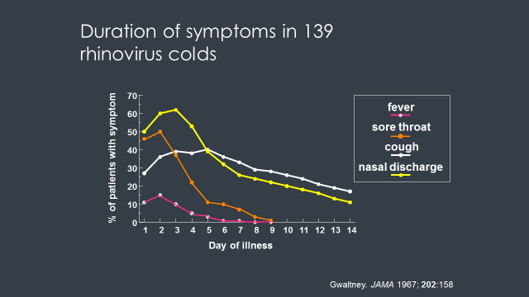
- When prescribing for common colds the following should be taken into consideration:
- According to this data antibacterial treatment should be limited to patients with:
  - prolonged nonspecific upper respiratory signs and symptoms (i.e. rhinorrhea and cough) without improvement for at least ten days
  - worsening of symptoms (i.e. fever of 39ºC, facial swelling, facial pain, maxillary tooth pain) after 5–7 days

The most common bacterial pathogens in the respiratory tractus are Moraxella (mainly URT), Haemophilus (influenza and parainfluenzae) and Pneumococcus. The resistance profiles for this organisms did not mutate and therefore basic beta lactam antibiotics (in adequate dosages) still remain the treatment of choice. Important however is to give high doses for a short duration (3 to 5 days). Should there not be an improvement within 48 hours, an atypical organism should be considered and a macrolide or doxycycline should be considered. Quinolones and cephalosporins should be avoided at community treatment level as it drives resistance of microbes.

Please phone us anytime if you want to discuss treatment or need advice!

